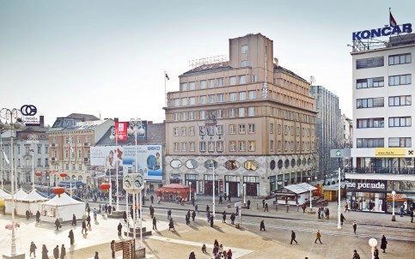

RESERVATION FORM FOR ACCOMMODATION

UFAW International Animal Welfare Science Symposium: Animal Populations – World Resources and Animal Welfare, Zagreb 14th - 15th July 2015

HSA International Symposium 2015: Recent Advances II, Zagreb 16th - 17th July 2015

Deadline to make reservation – 1st March 2015
After that date the availability of rooms at the special conference price can not be guaranteed.

NAME OF THE GUEST
NAME OF ACCOMPANYING PERSON
WHICH MEETING ARE YOU ATTENDING | Please tick required dates

DATE OF ARRIVAL
DATE OF DEPARTURE
NAME OF THE COMPANY
TELEPHONE, FAX, E-MAIL CONTACT
TYPE OF ROOM  Standard single room 630 kn approx 83 €  Double room for single use 706 kn approx 93 €  Double room for double use 860 kn approx 113 €  Deluxe room for single use 820 kn approx 108 €  Deluxe room for double use 980 kn approx 129 €  Extra charge city tax 1 EUR per person daily | Please tick required room type  - Standard single room [...]  - Double room for single use [ ]  - Double room for double use [ ]  - Deluxe room for single use [ ]  - Deluxe room for double use [ ]
METHOD OF PAYMENT
CREDIT CARD NUMBER/ EXPIRY DATE / CARD SECURITY CODE (last three digits on the signature strip on reverse of the card)
FREE CANCELLATION | 72 hours before arrival
PARKING SPACE ON REQUEST – rate per place per day 14 EUR | Please note if you need parking
RESERVATION CONFIRMED BY | Mladen Klemen- Groups supervisor  mklemen@hotel-dubrovnik.hr
Thank you for your confidence and best regards!
Please return this completed form to:
Mladen Klemen (Groups supervisor), Hotel Dubrovnik d.d. • Gajeva 1, HR-10000 Zagreb, Hrvatska-Croatia
• Tel. (+385 1) 48 63 504 • Fax: (+385 1) 48 63 507
www.hotel-dubrovnik.hr

Email: mklemen@hotel-dubrovnik.hr

